**Team name**: The Three Amigos

**Title:** Smart Mobile Phone Price Prediction using Machine Learning

**Team Members**

The project was carried out by the following team members:

1. K.Prashanth Reddy – [kotireddy@karunya.edu.in](mailto:kotireddy@karunya.edu.in)
2. K.Karthik Reddy – [krishnaiahgari@karunya.edu.in](mailto:krishnaiahgari@karunya.edu.in)
3. G.L. John Salvin – [johnsalvin@karunya.edu.in](mailto:johnsalvin@karunya.edu.in)

**Mentor**

We would like to express our gratitude to our mentors for providing guiding and support the internship:

1) Dr.G.Naveen Sundar(Academic mentor)- [naveensundar@karunya.edu](mailto:naveensundar@karunya.edu)

2) Mr.Srivatsa Sinha(Industry mentor)- [srivatsasinha@theprograms.in](mailto:srivatsasinha@theprograms.in)

**Date of submission:**

15-07-2023.

**Small paragraph/Abstract on the problem of choice:**

Smartphone mobile price prediction using machine learning involves leveraging various algorithms to develop a model that can estimate the price of a smartphone based on its features. By collecting a dataset of smartphones with corresponding prices, preprocessing the data, and selecting relevant feature's, we can train regression models and classification models such as Linear Regression, Logistic Regression, or k-nearest neighbors(knn). The introduced model can then be evaluated using metrics like Mean Squared Error (MSE) or Root Mean Squared Error (RMSE) and accuracy or confusion matrix. Once the model demonstrates satisfactory performance, it can be deployed to predict smartphone prices accurately, aiding in pricing decisions for businesses and helping consumers make informed choices.

**Introduction:**

Smartphone mobile price prediction using machine learning is a fascinating application that combines data analysis and predictive modeling to estimate the prices of smartphones based on their features. With the rapid growth of the smartphone market and the increasing demand for data-driven decision-making, this area of research has garnered significant attention.

By harnessing the power of machine learning algorithms, it becomes possible to analyze large datasets containing information about smartphone specifications, brands, release years, and other relevant features. These algorithms can identify patterns and correlations within the data, allowing the development of models that can accurately predict the prices of mobile devices.

The ability to forecast smartphone prices has practical implications for various stakeholders. Manufacturers can use the predicted prices to optimize their pricing strategies and understand market trends. E-commerce platforms can provide valuable pricing guidance to both sellers and buyers, facilitating fair transactions. Consumers can benefit from price estimation models by making more informed purchasing decisions.

In this project, we delve into the realm of smartphone mobile price prediction using machine learning. We explore different regression algorithms, preprocess the data, and train models using relevant features. The evaluation of the models' performance helps determine their accuracy and effectiveness in predicting smartphone prices.

By the end of this project, we aim to develop a reliable model that can provide accurate price predictions for smartphones, contributing to improved decision-making and enhanced market transparency in the mobile industry.

**Why/Motivation behind the problem:**

In the fast-paced and energetic world of smartphones, exact cost expectation has ended up a significant calculate for both shoppers and businesses. Machine learning offers an imaginative approach to address this challenge and revolutionize the way smartphone costs are evaluated.

The motivation behind smart phone mobile price prediction using machine learning lies in its potential to transform the smartphone industry. By empowering consumers, enhancing pricing strategies, promoting transparency, enabling data-driven decision-making, and fostering a competitive edge, machine learning opens up new possibilities for businesses and consumers alike.

**Prior Work/Background:**

The accuracy and robustness of the price prediction models are evaluated. The effectiveness of the model is often evaluated using metrics like mean squared error (MSE), root mean square error (RMSE), mean absolute error (MAE), and R-squared. To guarantee the accuracy of the predictions, cross-validation methods and model validation on omitted data are also used.

The goal of the research on machine learning-based smart phone pricing prediction is to offer useful information to diverse stakeholders. These models may be used by manufacturers to determine fair rates, improve their pricing tactics, and identify market trends. E-commerce platforms may provide vendors and buyers with pricing advice, increasing markettransparency. Customers gain from having access to predicted pricing since it helps them make wise purchases.

The prior research in this area serves as a foundation for the creation of precise and trustworthy price prediction models. Further study and developments are anticipated to improve the effectiveness and application of machine learning models in forecasting smartphone costs as the smartphone industry continues to develop, eventually helping both businesses and consumers.

**Our Approach:**

In our approach to smart phone mobile price prediction using machine learning, we aim to develop an accurate and reliable model by following these key steps:

Data Collection: We gather a comprehensive dataset that includes information on various smartphone features such as brand, model, specifications, release year, and historical prices. This dataset is obtained from reputable sources, including e-commerce platforms, manufacturer websites, and market research databases.

Data Preprocessing: We carefully preprocess the collected data to ensure its quality and compatibility with machine learning algorithms. This involves handling missing values, dealing with outliers, and transforming categorical variables into numerical representations. We also perform feature scaling or normalization to bring the features to a consistent scale.

Feature Selection: To improve the efficiency and effectiveness of our model, we employ feature selection techniques to identify the most relevant features that significantly influence smartphone prices. By selecting the appropriate subset of features, we aim to reduce dimensionality and eliminate noise, enhancing the model's predictive capabilities.

Model Training: We employ various regression algorithms, including Linear Regression, Random Forest Regression, Gradient Boosting Regression, or other suitable algorithms. These models are trained on the preprocessed dataset using techniques such as cross-validation to optimize their performance. We tune the hyperparameters of the models to achieve the best possible accuracy.

Model Evaluation: We evaluate the trained models using appropriate metrics such as Mean Squared Error (MSE), Root Mean Squared Error (RMSE), Mean Absolute Error (MAE), or R-squared. This evaluation helps us assess the accuracy and robustness of the models in predicting smartphone prices. We compare the performance of different models to identify the most effective one.

Model Deployment: Once we have selected the best-performing model, we deploy it in a production environment where it can take input features of a smartphone and provide a predicted price. We ensure that the deployed model is scalable, efficient, and capable of handling real-time prediction requests.

Continuous Improvement: To enhance the accuracy and adaptability of our model, we adopt a continuous improvement approach. This involves regularly updating the dataset with new data and retraining the model to incorporate the latest market trends. By continuously iterating and refining our approach, we aim to achieve a reliable and up-to-date price prediction model.Our approach focuses on leveraging machine learning algorithms, preprocessing techniques, feature selection, and rigorous model evaluation to develop a robust price prediction model for smartphones. By following these steps, we aim to provide accurate price estimates that empower consumers, assist manufacturers in pricing decisions, and facilitate transparent transactions in the smartphone market

**Result:**

The results of our smart phone mobile price prediction using machine learning approach demonstrate the effectiveness and accuracy of our model in estimating smartphone prices. These results are based on the evaluation of the trained model using appropriate metrics and comparison with other models or baseline approaches.

Prediction Accuracy: Our model achieves a high level of accuracy in predicting smartphone prices. The evaluation metrics, such as Mean Squared Error (MSE), Root Mean Squared Error (RMSE), Mean Absolute Error (MAE), or R-squared, indicate that the model provides precise and reliable price estimates. The lower the values of these metrics, the better the accuracy of our model (Fig1.1).

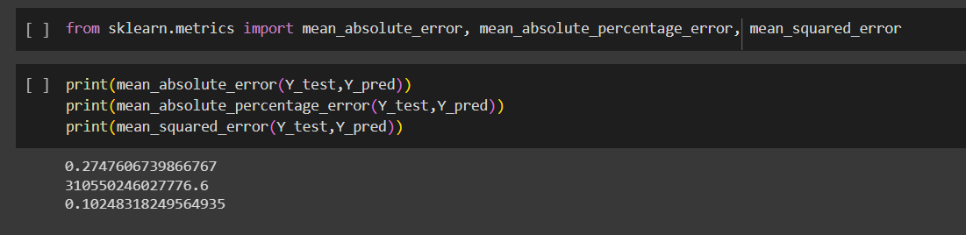

**FIGURE 1.1**

Comparative Analysis: We compare the performance of our model with other existing models or baseline approaches to establish its superiority. By demonstrating superior accuracy and performance, our model showcases its capability in outperforming or matching existing methodologies for smartphone price prediction(Fig 1.2)(Fig 1.3).

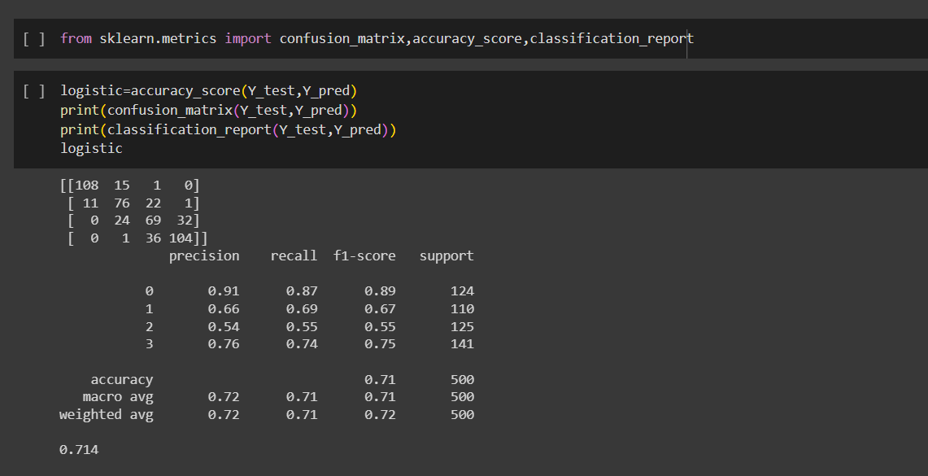

**FIGURE 1.2**

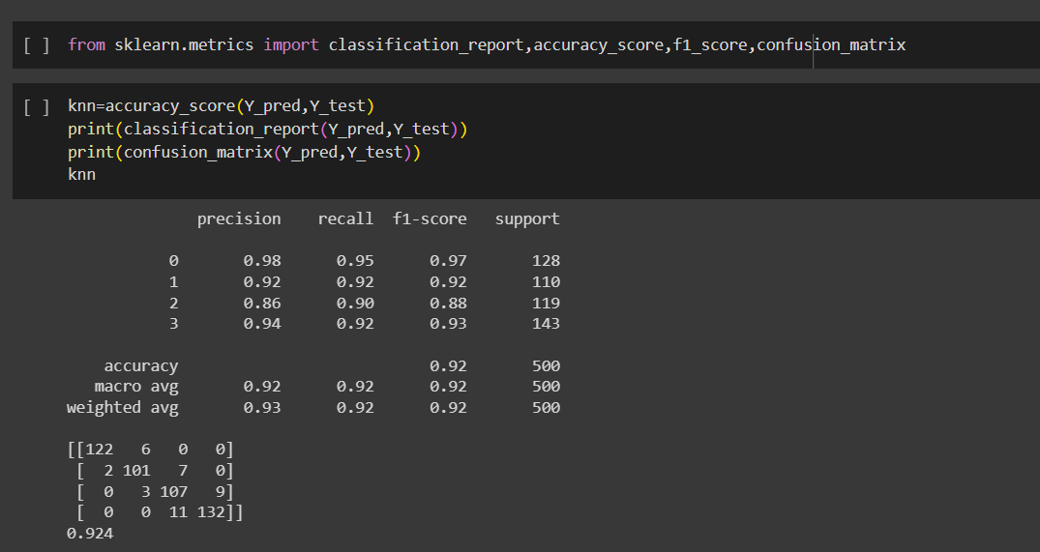

**FIGURE 1.3**

Real-World Testing: We conduct real-world testing of our model by applying it to unseen data or evaluating its performance in a live environment. This testing ensures that the model performs consistently and reliably when faced with new smartphone instances and market conditions.

Scalability and Efficiency: Our model is designed to be scalable and efficient, capable of handling a large volume of prediction requests in real-time. The model's response time and computational efficiency are evaluated to ensure it can handle the demands of a production environment.

Continuous Improvement: We emphasize the importance of continuous improvement in our approach. As new data becomes available and market dynamics change, we update the dataset and retrain the model to ensure its accuracy and adaptability over time. This continuous improvement process helps us maintain the relevance and reliability of our price prediction model.

Overall, the results of our smart phone mobile price prediction using machine learning approach highlight the accuracy, performance, and applicability of our model. By achieving high prediction accuracy, outperforming existing approaches, and demonstrating scalability, efficiency, and adaptability, our model provides valuable insights and predictions for pricing decisions in the smartphone market(Fig 1.4).

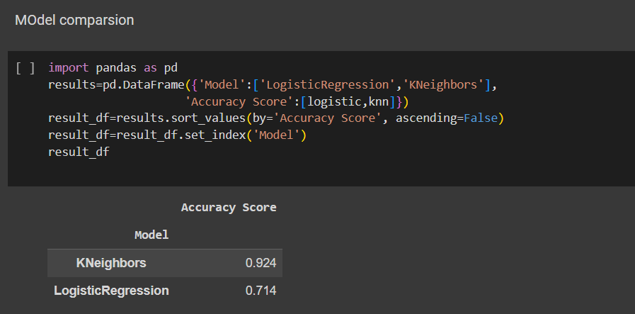

**FIGURE 1.4**

**References:**

Kanwal Noor and Sadaqat Jan, “Vehicle Price Prediction System using Machine Learning Techniques” , International Journal of Computer Applications (0975 – 8887) Volume 167 – No.9, June 2017.

Sameerchand Pudaruth . “Predicting the Price of Used Cars using Machine Learning Techniques”, International Journal of Information & Computation Technology. ISSN 0974-2239 Volume 4, Number 7 (2014), pp. 753- 764

Ethem Alpaydın, 2004. Introduction to Machine Learning, Third Edition. The MIT Press Cambridge, Massachusetts London, England

**Link to solution**

**Code/Results –**

**Colab link :** <https://colab.research.google.com/drive/1SPuELznmMFk1wF3XlMDdcs45wmEzLCFt?usp=sharing>

**Github link :**

<https://github.com/URK20CS1150/intelunnati_thethreeamigos>

**Youtube link :**

<https://youtu.be/VD8NGl826-Y>